Solving the Jackson Water Crisis:
A Position Paper

Jackson’s unsafe, unreliable water issue is an education issue.

Presented by
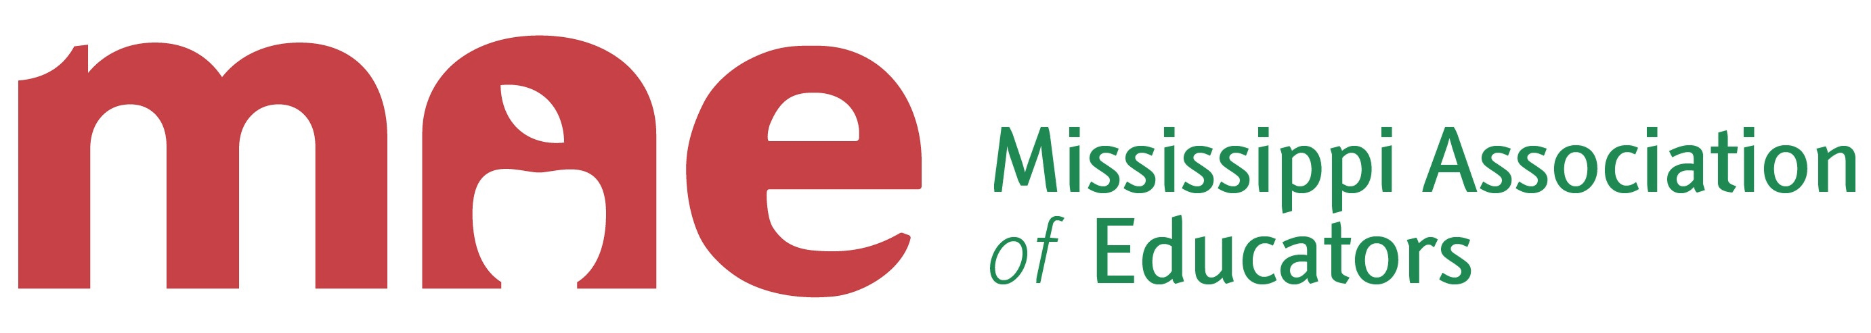
The Mississippi Association of Educators
August 8, 2022
MAE Headquarters
775 North State Street
Jackson, Mississippi

JACKSON WATER CRISIS
POSITION PAPER

Background: Jackson’s unsafe, unreliable water issue is an education issue.
Vision: Jackson students deserve access to safe and reliable water at home and at school.
This paper consists of findings and recommendations gathered from a Mississippi Association of Educators survey and other research endeavors. We have recognized that the Jackson water crisis is a threatening and on-going matter with new issues being exposed almost daily.
Our purpose is to provide Mississippi policy makers with an evidence-based template of citizens’ experiences and a plan for addressing this issue that will continue to worsen without swift, organized, and funded action.
It is our intention to work collaboratively with other stakeholders to support policy makers in their efforts to accomplish these goals. We will rely on open lines of communication and collaboration to achieve what our students and communities deserve.

THE WATER SAFETY SURVEY
The Mississippi Association of Educators launched a Jackson Water Safety Survey during April 2022 to assess the following information:
- The effect and impact that the substandard water system plaguing our Capital City has on our students, educators, and neighborhoods
- To determine the best steps to alleviate the threat the water system poses.
Our mission was to gain information on the issue from citizens and community stakeholders, research applicable background information that would inform the best solutions for our community in Jackson, and begin our advocacy on this issue by distributing that information to policy makers.
We interfaced with Jackson citizens about this issue at Vowell’s Cash Saver (2101 Raymond Road, Jackson, MS 39212), Piggly Wiggly (225 Meadowbrook Road, Jackson, MS 39206), Oops All Vegan (4409 North State Street, Jackson, MS 39206), Vowell’s Marketplace (5777 Terry Road, Byram, MS 39272), and Hilltop Church Resource Center (785 North President Street, Jackson, MS 39202). In addition, individuals were polled by telephone and online.
This report provides findings and recommendations gleaned from the survey and includes background information regarding the ongoing and dangerous threat of lead-tainted, foul water on Jackson’s students, educators, and neighborhoods.
SURVEY FINDINGS
The Jackson Safe Water Survey launched on April 20, 2022, via the Mississippi Association of Educators website. It was subsequently employed during person-to-person interfaces at public venues and by telephone.
Following are the questions included in the MAE survey:
- Has your family experienced tap water issues (examples: no running water, low pressure, discolored/foul smelling water, boil notice) at home?
- Has a student in your family or neighborhood experienced tap water issues (examples: no running water, low pressure, discolored/foul smelling water, boil notice) at school?
- If you answered yes to the questions above, how long did those issues persist?
- Do you spend money on bottled drinking water?
- Do you feel that tap water in Jackson is safe to drink?

DATA SUMMARY

THE BACKGROUND RESEARCH
The Mississippi Association of Educators undertook a research project to ascertain the history and extent of documented safe water issues in Jackson. We found that significant information was not readily available or had to be obtained under a Freedom of Information Act filing. While we recognize this research does not rise to dissertation level, we are confident in the findings and recommendations it has produced. We have provided research sources as an appendix to this paper.
RESEARCH FINDINGS
Dangerous and unreliable water is particularly harmful to children and their families with developmental, health, and economic impacts felt for generations.
Affected families must spend money on safe water rather than other needs, leaving many without wholesome living necessities.
When the water system fails, JPS schools are forced to transition to online learning, destabilizing students’ learning environments and putting more economic strain on families who now must choose between taking off work or hiring childcare if that is an option. Moreover, with the unplanned transition to online learning, access to free and reduced breakfast and lunch becomes an additional challenge for students.
Businesses and residents are reluctant to settle or stay in an area where water is inadequate or dangerous. This reluctance negatively affects both economic development and quality of life for residents.
The long-term physiological effects of lead poisoning result in a lower performing work force and general decrease in productivity, with impacts of cognitive impairment on the economy subtle yet powerful.
The Lead Safe Housing Act implementation in Jackson is inadequate in identifying and repairing homes that are at risk of lead poisoning within their water systems.
RESEARCH SUMMARY
The Jackson water system is inadequate in many ways and flawed at all levels of infrastructure. It has operational and maintenance issues at the water treatment level. It has aging and outdated infrastructure within its mainline systems. Many of its service lines are made from outdated and dangerous materials such as lead and galvanized pipe. Finally, the plumbing inside of approximately 70% of Jackson homes was made using some lead components. Each level of infrastructural inadequacy compounds the issues of an aging and outdated water system.
The Jackson water system is prone to catastrophic failure. The existing infrastructure instability is the result of negligence with disastrous results. Unless the issues are addressed, the city’s habitual water outages will become more frequent and with larger impact.
The composition of the system is dangerous. Lead and galvanized and cast-iron pipes make up large portions of the city’s infrastructure. These aging pipes composed of dangerous and degraded materials will continue to block Jackson’s development efforts if they remain unaddressed.¹
This project will not be cheap, but the consequences of inactivity will be realized at far greater human and economic cost. Comprehensive investment in the capital city’s water infrastructure to alleviate the current issues should result in more businesses and citizens remaining in the city and contributing to the overall economy of both Jackson and the State of Mississippi.
¹ The Jackson water system has multiple lead risk factors, including lead joints in old cast iron piping, lead service lines for majority of houses, and lead solder on copper piping within homes. These risk factors culminated in sharp increase in lead levels in 2015. This was linked broadly to the failures to implement proper corrosion control methods in the O.B. Curtis water treatment plant (Wolfe). The city has continued to receive a “Treatment Technique Violation” from the EPA for the last 4 years of testing Since 2019 the city has remained an enforcement priority for the EPA under the lead copper rule. Oldest houses are most at risk given the more relaxed lead standards before 1986. Approximately 74.1% of housing units in Jackson were made before the 1980’s. This impacts all buildings in Jackson built before 1986. The vast majority of Jackson has some sort of lead exposure. From discussion I had with O.B. Curtis water treatment lab staff the pH varies throughout the system. This means even if the Treatment plant does control the pH exiting the plant it could easily become dangerous as it passes through the system. This is a best-case scenario which we have seen fail in the past. As we have discussed the ability of the system to properly control the pH of the water is dependent upon numerous factors which have failed before with dangerous results.

LEGISLATIVE REVIEW
We performed a review of 2022 Legislative efforts to fund adequate infrastructure repairs, maintenance, and natural water flow influences on the Jackson Water System. Members of the Jackson delegation filed measures to improve and fix the situation.
LEGISLATIVE FINDINGS
All Legislation introduced during the 2022 session that would have allowed bonds for repairs on the Jackson Water Crisis died in committee.
Legislation that would have provided funding for city creek drainage issues that also affect the water system died in committee.
A portion of the $1.8 billion ARPA grant to Mississippi was set aside to fund matching grants for water system repairs for cities and counties. These grants are being overseen by The Mississippi Department of Environmental Quality for the City of Jackson.
LEGISLATIVE SUMMARY
Despite ongoing infrastructure issues that result in unsafe and unreliable water for the Capitol Area Complex and the metro area that supports it, the Mississippi State Legislature has consistently refused to consider direct legislation designed to aid in the alleviation of the Jackson water crisis issue.

RECOMMENDATIONS
- We recommend that the Mayor of the City of Jackson issue a proclamation declaring that fixing the ongoing water crisis and securing safe and reliable water access in Jackson will be made the first priority of the administration.

- We recommend that a fully developed, structural plan, including projected costs and timeline to completely repair Jackson’s water system be made public for comment and input by the citizens of Jackson and community stakeholders no later than September 1, 2022, and include proposed necessary legislative action to achieve the plan stated outcome.

- We recommend that the Mississippi State Legislature and State Leadership levy its immediate attention on the Jackson Water Crisis and provide a plan for funding improvements not covered by the ARPA grant program during the 2023 session and as defined in the aforementioned comprehensive program recommendation in order to stop the continued danger posed to students and citizens by the system’s failure.

- We recommend that government, community, education, and faith representatives form the Jackson Safe Water Crisis Coalition in order to monitor the above recommendations, meet monthly in a communicative and collaborative effort, establish an online presence, and be a leading, non-partisan group that advocates for these positive changes for our city and state.

APPENDIX
SOURCES:
Otts, Stephanie. Catharine Janasie “How Safe is the Water?: An Analysis of the Lead Contamination Risks of Public Water Supplies in the Mississippi Delta” University of Mississippi, December 2017 https://nsglc.olemiss.edu/projects/lead-contamination/files/howsafeiswater.pdf

Wolfe, Anna “Jackson hit with technical violation for water treatment” Clarion Ledger, 2016 www.clarionledger.com/story/news/local/2016/06/09/jackson-issued-technical-violation-water-treatment/85618558/
Wolfe, Anna “Jackson water system contains lead joints” Clarion Ledger, 2016 www.clarionledger.com/story/news/local/2016/03/15/city-water-system-has-some-lead-joints/81780766/

EPA “Detailed Facility Report” Environmental Protection Agency Enforcement and Compliance History Online, 2021 https://echo.epa.gov/detailed-facility-report?fid=MS0250008&sys=SDWIS#SDWA_Lead_and_Copper_Rule_01/01/2016_TT

“Water Quality Challenges in Jackson, Mississippi: A Story Map” The University of Mississippi 2020,https://olemiss.maps.arcgis.com/apps/MapJournal/index.html?appid=816b40d4f0e74c6c819dc543fdf3e2cf .
EPA “Use of Lead Free Pipes, Fittings, Fixtures, Solder, and Flux for Drinking Water” United States Environmental Protection Agency, 2022 www.epa.gov/sdwa/use-lead-free-pipes-fittings-fixtures-solder-and-flux-drinking-water
US Census Bureau “S2504 Physical Housing Characteristics for Occupied Housing Units” US Census Bureau, https://data.census.gov/cedsci/table?q=Jackson%20MS%20housing&tid=ACSST5Y2020.S2504
LSLR Collaborative “Introduction to Lead and Lead Service Line Replacement” LSLR Collaborative, https://www.lslr-collaborative.org/intro-to-lsl-replacement.html
AWWA “Rehabilitation of Water Mains” Manual of Water Supply Practices, ed 3, American Water Works Association 2014.
BOWEN, SARAH, et al. “Rural Food Insecurity: A Longitudinal Analysis of Low-Income Rural Households with Children in the South.” RSF: The Russell Sage Foundation Journal of the Social Sciences, vol. 8, no. 3, 2022, pp. 50–77. JSTOR, https://www.jstor.org/stable/48663795. Accessed 21 Jun. 2022.

Ganacheau, Adam. “Cities and counties will soon spend $1 billion in water, sewer upgrades as inflation rises.” Mississippi Today, July 2022. Water, sewage: $1B in upgrades to be spent - Mississippi Today
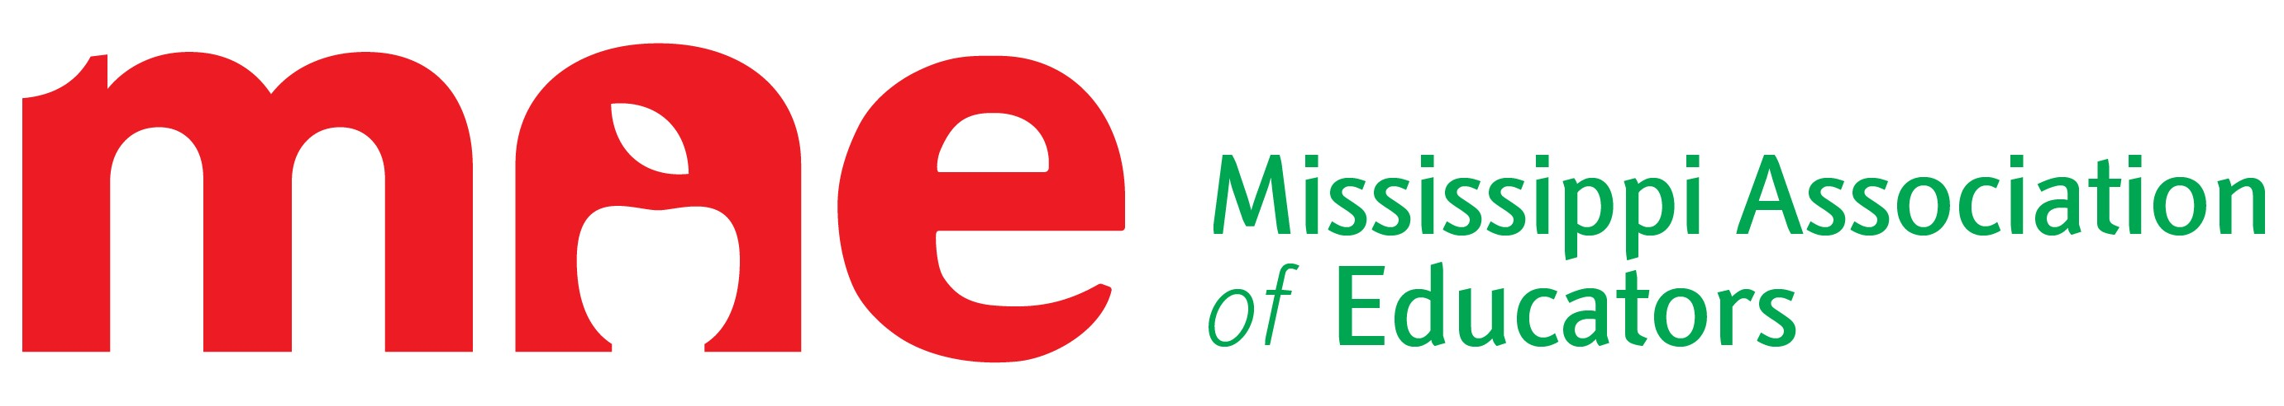
775 North State Street
Jackson, MS 39202
(601) 354-4463

